ONLINE

HOTEL

MANAGEMENT

SYSTEM

# INTRODUCTION

This is a Project work. We have tried our best to make the complicated process of Online Hotel Management System as simple as possible using Structured & Modular technique & Menu oriented interface. We have tried to design the software in such a way that user may not have any difficulty in using this package & further expansion is possible without much effort. Even though I cannot claim that this work to be entirely exhaustive, the main purpose of my exercise is perform each activity for booking a hotel in computerized way rather than manually which is time consuming.

This is a user friendly online hotel booking system. Only user can perform their hotel booking’s regarding activities using this website. Users can login in to this system and check available hotels in their favorite place. They can choose their hotel and book it using this system.

New user can register in this system to book their favorite hotels .To register in this system user only provide their personal details.

# PROJECT TOOLS

**1.Xampp Software** (XAMPP is a free and open-source cross-platform web server solution stack package developed by Apache Friends, consisting mainly of the Apache HTTP Server, MariaDB database, and interpreters for scripts written in the PHP and Perl programming languages)

**2. VISUAL STUDIO CODE** (Visual Studio Code is a source-code editor developed by Microsoft for Windows, Linux and macOS. It includes embedded Git and support for debugging, syntax highlighting, intelligent code completion, snippets, and code refactoring.)

**3. INTERNET EXPLORER** (graphical web browsers developed by Microsoft and included in the Microsoft Windows line of operating systems)

# 

# CODING LANGUAGES

1. HTML (Hypertext Markup Language is the standard markup language for documents designed to be displayed in a web browser)
2. CSS (Cascading Style Sheets is a style sheet language used for describing the presentation of a document written in a markup language like HTML)
3. JAVASCRIPT (**JavaScript** (JS) is a lightweight, interpreted, or just-in-time compiled programming language with first-class functions. While it is most well-known as the scripting language for Web pages)

4.PHP (PHP is a widely used server-side programming language that’s become increasingly fast and powerful over the years. PHP works well with HTML and databases, making it a great language for anyone interested in building dynamic web applications.)

5.SQL (SQL is a standard language for storing, manipulating and retrieving data in databases.)

***FRONT PAGE***

**When user go to this website , this page will open. This is the front page :**

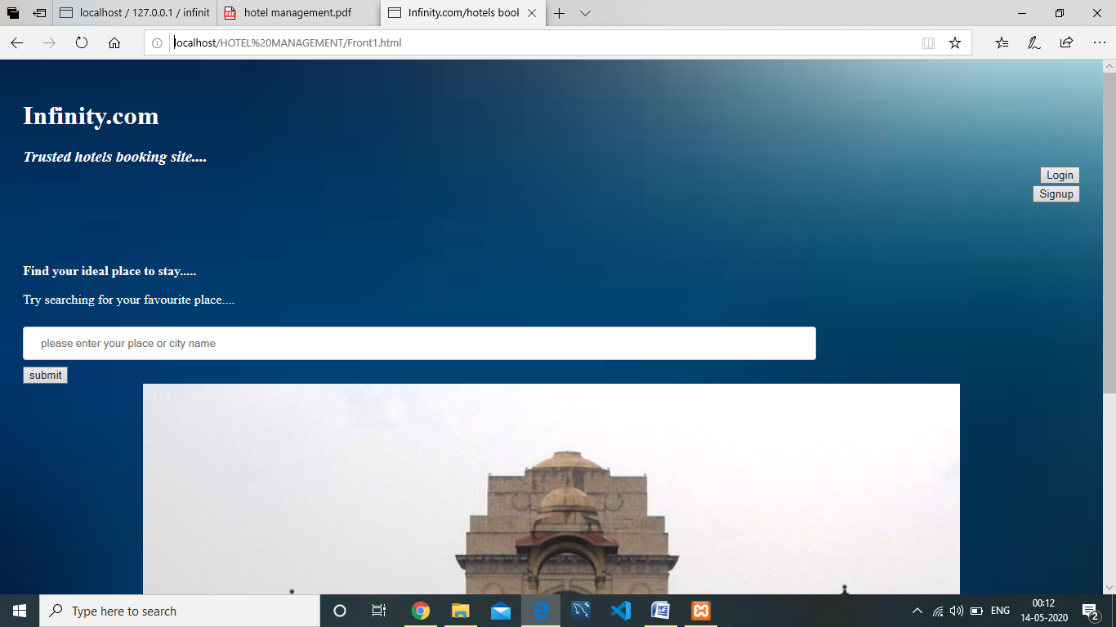

(Screenshot of Frontpage)

# 

# SIGNUP PAGE

If new user want to Register in this system , then click in **Signup Button** and go this signup page :

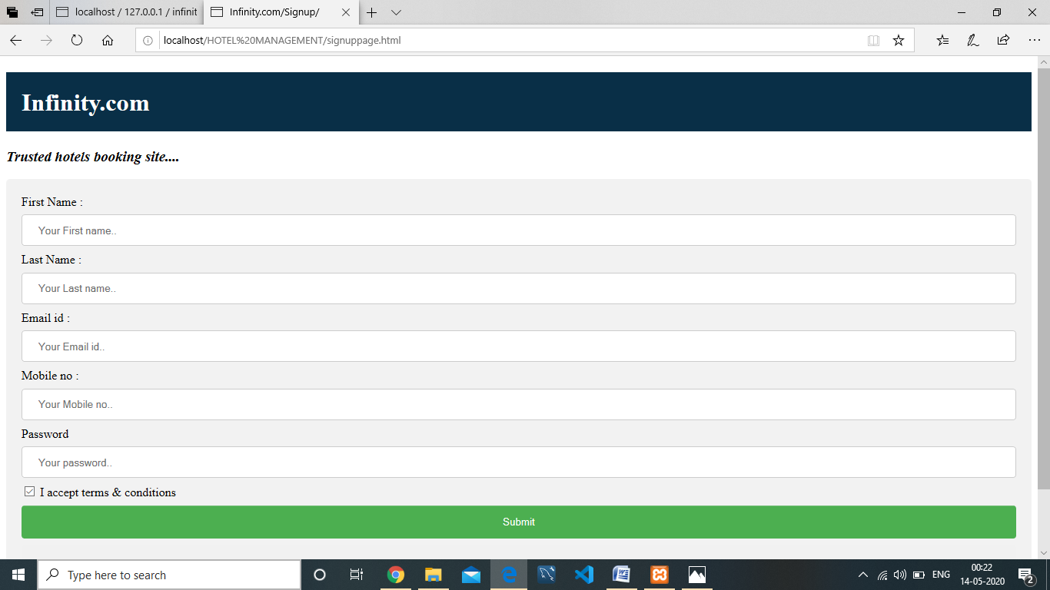

(Screenshot of signup page)

# 

# LOGIN PAGE

If User want to login this system then go to this page and provide email id and password .

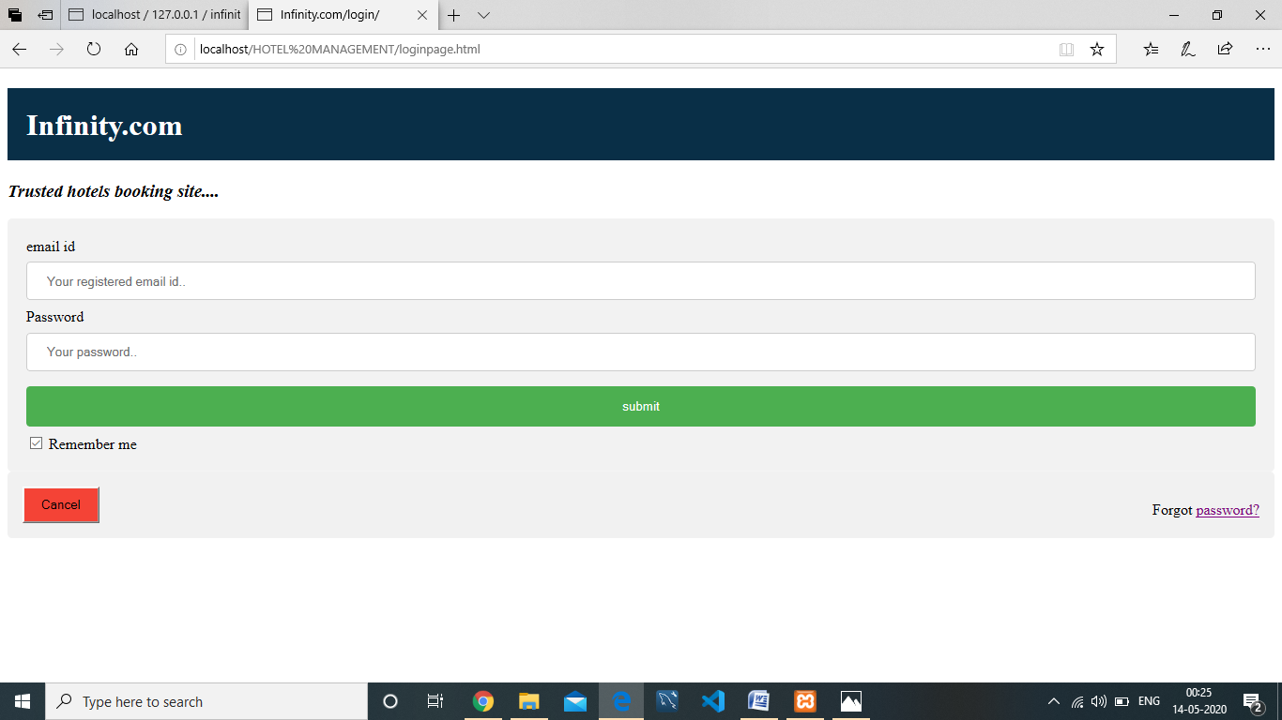

(Screenshot of Login page)

# 

# HOTEL SEARCH PAGE

When user want to search hotel then this page will come:

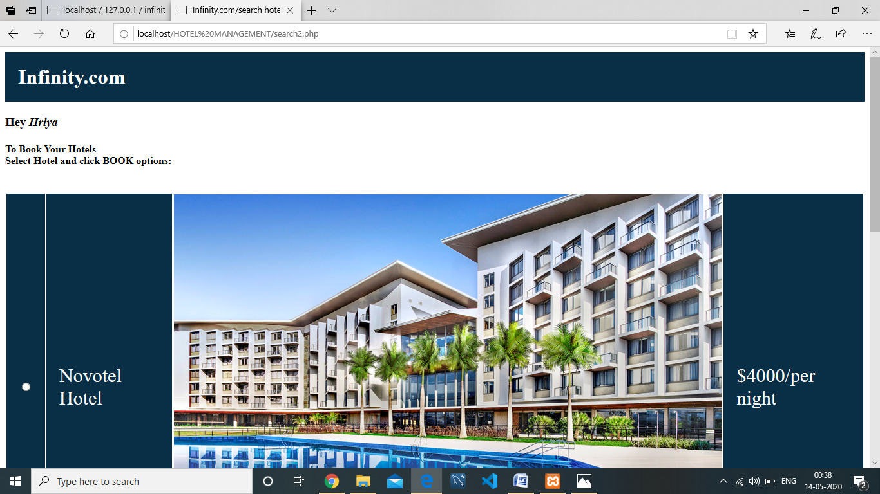

(screenshot of hotelsearch page)

# BOOKING PAGE

After selecting Hotel user go to this booking page to book a hotel :

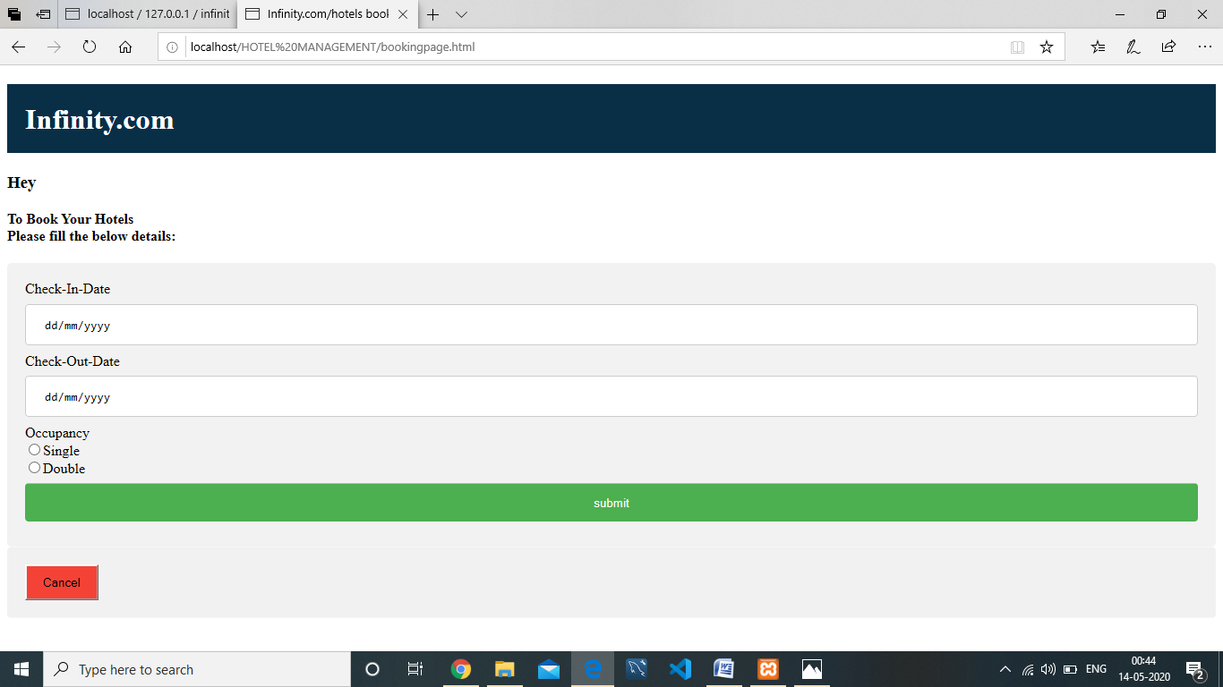

(Screenshot of booking page)

# 

# BOOKING HISTORY

If user want to see the booking historys then click **Booking history** button :

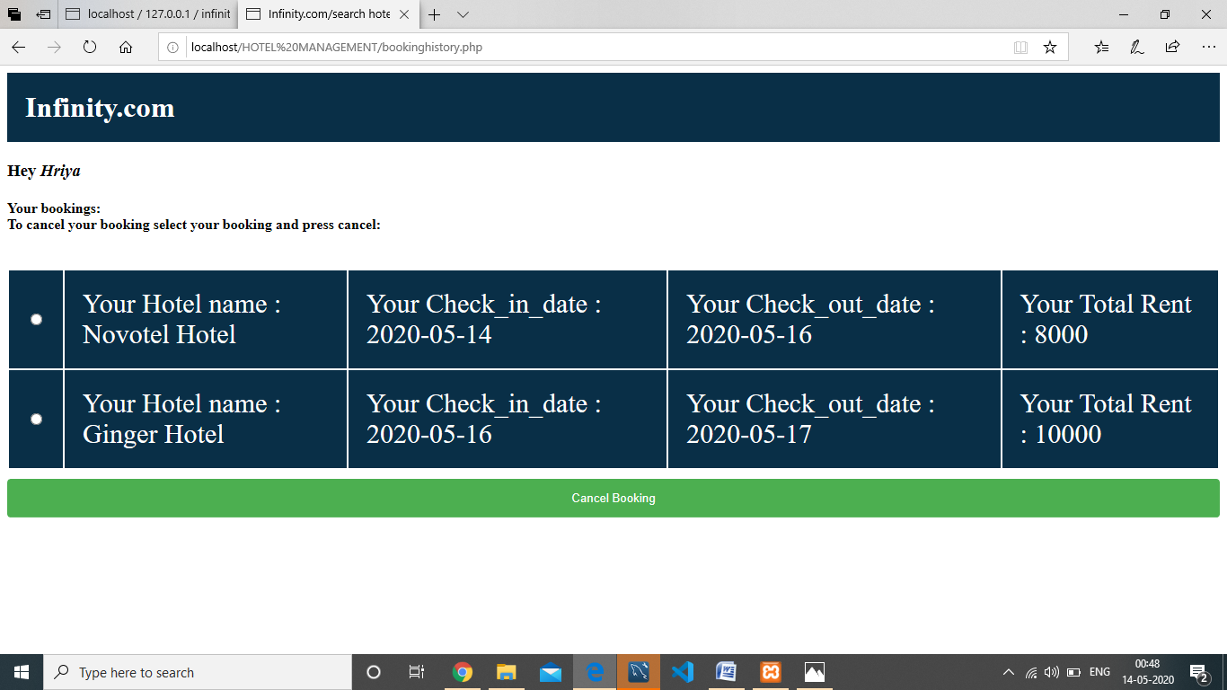

(Screenshot of Booking History page)

**PROCEDURE**

1. Download XAMPP control panel server .
2. Put HOTEL MANAGEMENT main folder in htdocs folder of XAMPP.
3. Start Apache and MySQL & go to admin.
4. Create one Database name :’infinity’.
5. Import infinity.sql file to the infinity database.
6. Go to the Browser and click :

<http://localhost/HOTEL%20MANAGEMENT/Front1.html>

**ADVANTAGES**

1. It saves user time in search of Hotels.
2. Easy Registration.
3. The system is effective and saves time and cost of users.

**DISADVANTAGES**

1. The booking process usually requires a customer all details which the system cannot detect.
2. It requires a reliable internet connection.

**REFERENCE**

1. <https://www.w3schools.com/>

**DRIVE LINK**

1. [**https://drive.google.com/open?id=1Vg9MEJQ7i9W4ff0MOnK-S-kWTUUm_zVZ**](https://drive.google.com/open?id=1Vg9MEJQ7i9W4ff0MOnK-S-kWTUUm_zVZ)

THANK YOU